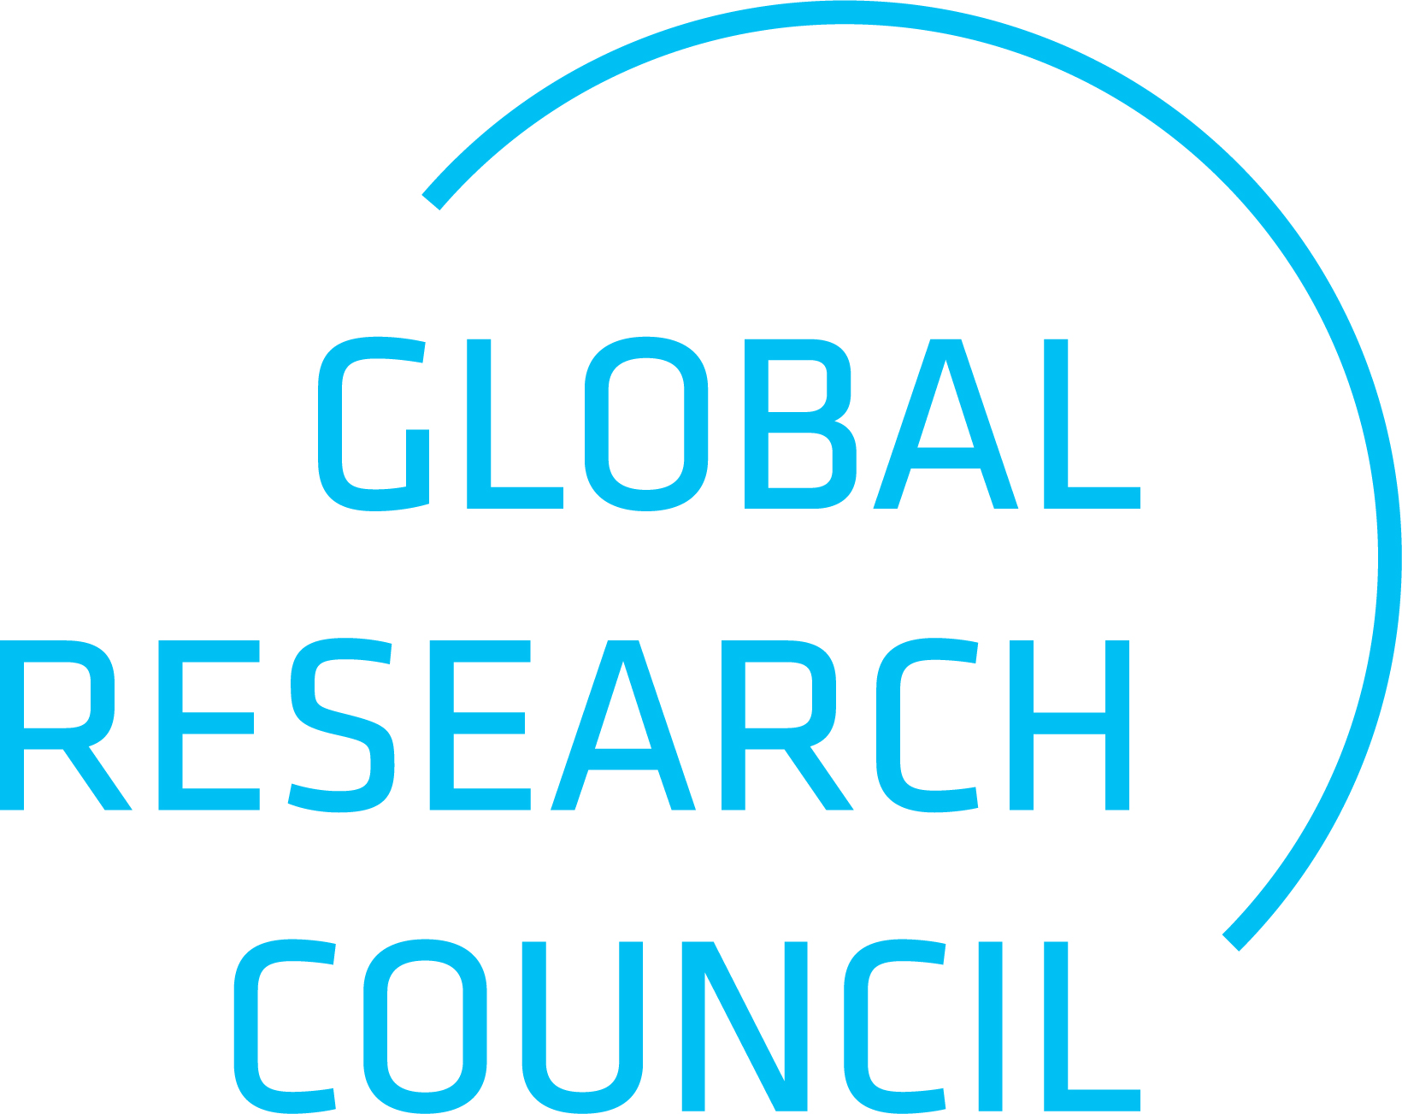
CALL FOR PROPOSALS

Global Research Council (GRC) Seeking Hosts for the 2029 Annual Meeting

APPLICATION FORM
Please return to grc@ukri.org by 25 January 2027

 | Host Research Council | Co-Host Research Council
Name of Council
Heads of Research Councils
Name
Email address
Main contact person(s) for the organisation of the meeting
Name
Email address

Proposed location
Proposed dates

Additional Information:

A short narrative, maximum of five (5) pages, in support of the application shall be appended to this
form, including:

- Background information about host and co-host(s)
- Strategic advantage of the partnership, roles of host and co-host(s)
- Vision and aim of the event / motivation of the applicants to host the meeting
- Optional: Proposal of topic(s) for the GRC cycle leading to the 2029 Annual Meeting, expanding on:
- The relevance of the topic(s) for GRC participating organisations and the wider scientific community
- Potential pre- or side-events
- Potential linkages to other scientific activities

Please submit to grc@ukri.org by 25 January 2027

The Annual Meeting should take place in late May/early June and last around 2.5 days, with an additional 1-2 days suggested prior to the Meeting for pre-events and side meetings.
Brief introduction and previous engagement with the GRC

