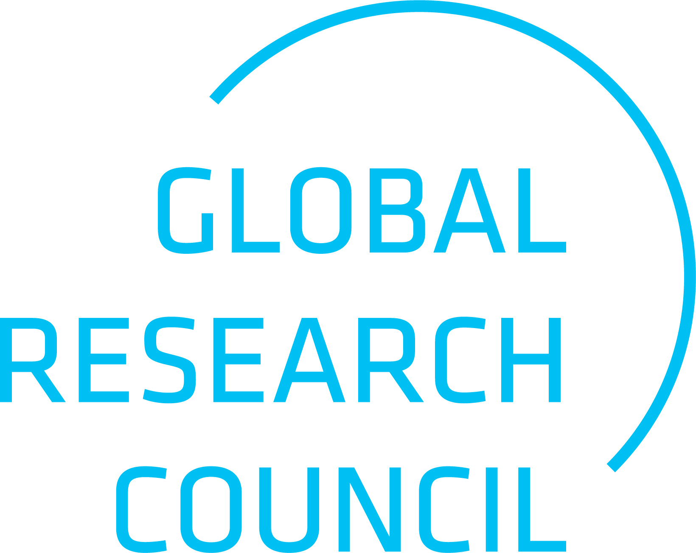
CALL FOR PROPOSALS

Global Research Council (GRC) Seeking Hosts for the 2028 Annual Meeting

APPLICATION FORM

 | Host Research Council | Co-Host Research Council
Name of Council
Heads of Research Councils
Name
Email address
Main contact person(s) for the organisation of the meeting
Name
Position/Job title
Email address

Proposed location
Proposed dates

Additional Information:

A short narrative, maximum of five (5) pages, in support of the application shall be appended to this
form, including:

- Background information about host and co-host(s)
- Strategic advantage of the partnership, roles of host and co-host(s)
- Vision and aim of the event / motivation of the applicants to host the meeting
- Optional: Proposal of topic(s) for the GRC cycle leading to the 2028 Annual Meeting, expanding on:
- The relevance of the topic(s) for GRC participating organisations and the wider scientific community
- Potential pre- or side-events
- Potential linkages to other scientific activities

The Annual Meeting should take place in late May/early June and last around 2.5 days, with an additional 1-2 days suggested prior to the Meeting for pre-events and side meetings.
Brief introduction and previous engagement with the GRC

